Cirel

A system to improve striking

Campanologists’ intelligent ringing error logger

Introduction and overview

Cirel is a system of sensors on bells, electronics and software that enables information about the timing of bells’ striking to be recorded and subsequently analysed for regularity.

It is useful to ringers who wish to review some ringing after it has taken place in order to check their striking or to see if they went wrong in the method. The rows that have been rung are presented in a visual format that allows the user to select a bell and view its ‘blue line’ to see how far from the ‘ideal’ line the bell actually rang. An example screen dump is shown below. The ringing of the treble bell is picked out. Its handstroke leads were a little late in rows 5 and 7. They were also a bit late in most of the handstroke rows shown, but not so bad as to be highlighted. The treble clipped bells 8 and 9 quite badly in rows 23 and 27.

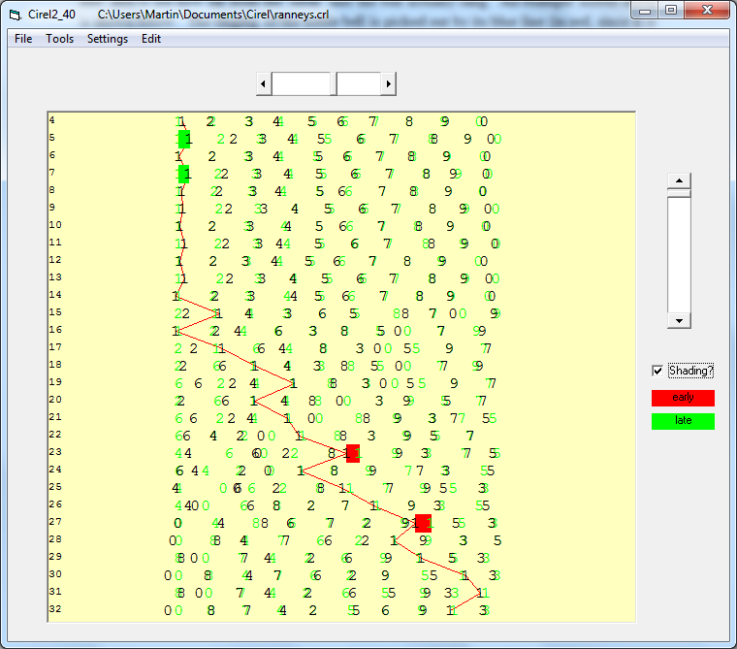

You can listen to the ringing through a sound card using pre-recorded bell sounds. You can choose to listen to the ringing as rung, or as corrected by Cirel. The ringing normally sounds very high quality in the latter case.

The various facilities include recording data from bells, saving recorded data to a file, opening a file of ringing data, analysing and displaying ringing data, and carrying out statistical analysis of ringing. Some facilities are also included for editing ringing data.

The ringing data files can be saved in binary format (Cirel format), or as text files (Lowndes Format), or as CSV files for spreadsheet analysis.

In order to record ringing inexpensive piezo-electric sensors are fixed to the bells. The electrical signals from these sensors are wired up to an interface box which is located in the bell chamber. A single cable connects the interface box to a COM port of a PC in the ringing room from where the system is controlled. The system is reliable and accurate and can deal with up to 12 bells.

User instructions

Recording ringing - from bells

Ensure power is supplied to the interface box, ensure that all bell sensors are connected, and that the box is connected to the PC via a COM port. If your computer doesn't have a COM port, you can connect via an FTDI cable and a USB socket.

Before ringing commences use the Tools/Record from Bells option (or CTRL-B). A dialogue box will pop up requiring you to enter the total number of bells about to be rung. Once this information is entered the system waits for ringing to start. It assumes that the first bell to ring is the treble, and will quit if this is not the case. When ringing ceases for more than 2 seconds the record function automatically ceases and another dialogue box pops up asking if the ringing should be saved to disk. Entering ‘Yes’ to this question allows the data to be recorded with no further information required. The data is saved on the C: drive as Cirel<n>-<date>.crl where the value of n and the date are supplied automatically.

If the user responds ‘No’ the data is still held in memory and can be saved later if required via the File menu. It will be over-written, however, if a new recording is made.

The 2-second time-out before recording ceases can be altered by means of the Settings dialogue box, discussed later.

Recording ringing - from keyboard

If you wish to experiment you can simulate bells ringing with key-presses on the keyboard. Instructions pop up when this option is chosen. The end of recording is signalled by pressing any key other than those used as bells.

Checking ringing

Use the Tools/Analyse and display menu to run an analysis of the ringing data currently in memory. You should get a display similar to the one shown on page 1. If it is significantly different there may be a problem with missing or additional bell data. It may be possible to correct the data using the Edit menu – see the section on Editing data.

If you wish to see the path a particular bell takes simply left-click on the bell to create its ‘blue line’. Shift-left-click will draw the line through the corrected (green) data for a possibly more recognisable line. Left-clicking again will hide the blue line.

When a bell has its blue line showing you can choose whether to view its striking errors by means of the Shading? tick-box. If it is judged to have rung early by more than the set threshold then a red marker shows; if late a green marker shows.

Listening to the ringing

By right-clicking on the displayed ringing you can hear what it sounds like. You need a sound card installed for this to operate. The playback starts from the row you clicked and continues to the end of the touch, or until you press the Escape key.

You can choose between a tower-bell sound, a hand-bell sound or a tubular bell sound, whichever you find most helpful when trying to hear certain features of the striking. You can stretch the timing, and you can also choose whether to listen to the ringing as recorded or as corrected by the Cirel software.

Listening to the corrected ringing allows you to judge the framework used by Cirel. If you have chosen the Alpha-Beta algorithm you should find that the corrected ringing does vary, but is still quite regular; the Double-row correction gives mostly very regular, high quality ringing.

Settings

You can choose between two correction algorithms when analysing ringing data: **Alpha-Beta** or **Double-row**. I am indebted to John Harrison who suggested the Alpha-Beta method, and to Richard Johnson who devised the Double-row analysis. The Alpha-Beta algorithm is generally more lenient than the Double-row method. For choppy ringing, the Alpha-Beta system ‘bends’ more to the actual ringing compared to the Double-row system. Use the Settings menu to choose which algorithm you wish to employ.

For either system you can set the expected **handstroke gap**. The default is exactly 2. In other words, the handstroke gap is expected to be exactly twice the normal gap between bells ringing. By clicking the tick-box next to the Handstroke factor field in the Settings dialogue you can get Cirel to calculate the actual average gap of the ringing, and use that figure as the expected (‘correct’) gap. It is possible that the calculated handstroke gap is given as 0.00. This can happen if the ringing fires out and incomplete rows are recorded. Use the default value of 2, or set to some other value manually if you wish. (If you use 0 an error message will be generated.)

**Error Threshold**: this is the size of the striking error a ringer can make before the software counts it. This figure is used for the error highlighting (Shading) in the visual display and also for the various statistical calculations you can request. The default is 50ms (one twentieth of a second.)

The **Ignore Threshold** instructs the analyser to ignore bells that strike a long way away from when they should ring. The default is set to 500ms (i.e. half a second). With this setting the software never ignores a blow. If you set the Ignore Threshold to a very low value the software will ignore *all* the ringing and get completely out of sync with the actual data, and the analysis will not be much use.

The user can alter the values of **Alpha** and **Beta**, as used in the Alpha-Beta method of analysing the striking. The Alpha value indicates how much weight Cirel gives to the actual time a bell strikes compared to when it thinks it should have struck; the beta value indicates how much weight Cirel gives to the intervals between ringing. To put it another way, Alpha controls how quickly Cirel adjusts to get in sync with the actual ringing while beta controls how quickly Cirel adjusts to the speed of the ringing. The default values are 0.4 and 0.1 respectively but you can try different values.

The Double-row algorithm calculates a moving average over the last two rows, taking the handstroke gap into account, of course. A linear regression algorithm is used for the first two rows of a piece of ringing.

The COM Port setting allows users to choose which COM port they use to attach the hardware. Default is COM1.

Finally, the End-of-ringing time-out figure determines how long Cirel waits before it thinks ringing has ceased. It automatically stops recording data from the bells if there is silence for a longer time than this setting. Default is 2 seconds.

Editing the data file

Occasionally it may be necessary to edit the recorded data file so that Cirel can analyse it. If the ringing is stopped with an incomplete row then some of the calculations cannot be done, and in this case the incomplete row can be deleted. When the hardware was at an early stage of development occasional blows were lost, or the same blow was recorded twice, so facilities were developed for editing individual blows. The present hardware is very reliable, however, so these edit facilities are unlikely to be used extensively.

The edited data can be saved to hardware using the File/Save As facility. The data will be saved as a binary format file (.crl).

**Time sort**

When Cirel records data it attempts to sort out rows so that each one contains all the different bells, just once. For instance, at the first pull-off the treble may ring at backstroke before the tenor has rung its first handstroke. Cirel will allocate the second blow of the treble to the second row. If the ringing gets very poor the software may get these corrections wrong. The Time sort facility presents the data in purely time order. It may then be easier to see what was actually going on. You can choose the row from which the data should be sorted.

**Row sort**

This facility attempts to convert a time-sorted data file into row-sorted. If it is already row-sorted no changes will be made.

**Check missing**

This checks that there are no blows missing from the data file. The software simply checks that the gap between a bell ringing and then ringing again is never greater than 3 seconds.

**Check double**

This checks that there are no occasions when a bell is recorded as ringing twice within one second.

**Delete from row...**

This facility allows the user to delete the data from a chosen row. All rows after and including the chosen row will be deleted.

**Shift-right-click**

This facility allows a user to edit an individual row using the mouse. The options are to delete the blow pointed to, or to add in an extra blow.

As explained above, these facilities were added when the recording hardware was somewhat unreliable, which rendered the analysis software unusable. The current design of the hardware appears to be very reliable and most of these edit facilities are no longer necessary.

File menu

**Print**

Facility to print to the default printer attached to the printer port of the PC. Gives a printout similar to that on the main display, i.e. row numbers, blows recorded, blue line (if selected), and error shading (if selected). Facilities for setting the start and end row, and number of rows per page are provided.

This facility has not been extensively tested.

**Open (Cirel)**

Facility to load a data file of bell ringing data, recorded as a Cirel (.crl binary) file. Once the file has been loaded a message box pops up informing the user how many rows have been loaded. The data is then automatically analysed and the results displayed.

**Open (Lowndes)**

Mike Lowndes was involved with the development of the Strikeometer system and he devised a text format for recording bell striking data. Cirel can read such .txt files and then analyse the data in the same way as if it was recorded by the Cirel system.

**Save as...**

This facility allows a user to save a data file as a .crl binary file. It allows the user to choose the location and name of the destination file.

**Export as csv**

This facility enables the ringing data to be exported in a comma-separated variable file format. This may be useful for users who wish to analyse the ringing using their own spreadsheet methods. The destination file is in the same location as the currently opened .crl or .txt file, but will have the extension .csv

**Export as Lowndes**

This facility allows a user to save some ringing data as a Lowndes-format (.txt) file. The destination file is in the same location as the currently opened .crl or .txt file and will have the extension .txt

**Export corrected**

This facility allows a user to save the 'corrected' ringing data as a .crl file. The user can choose the name and location of the saved file.

Tools menu

**Analyse and display**

This facility analyses the ringing data currently held in memory according to the various settings (see p4), and then displays the results in the main window. This facility runs automatically when a file is loaded (opened) using the File menu.

**Record ringing...**

This facility enables the software to capture ringing data as ringing (or keyboard tapping) takes place. For further information see p2.

**Striking judgements...**

This facility allows the user to choose between various ways of making an overall judgement on the quality of striking of a piece of ringing.

The *Standard Deviation* option causes a pop-up message box to inform the user of the average gap between blows (taking into account the handstroke gap), the standard deviation of this variable, and the size of the standard deviation as a percentage of the average gap.

The *Gap Errors* option causes a pop-up message box to inform the user of the number of gap errors, the prevailing error threshold, and the size of the gap error per blow. A gap error is counted when the actual gap between two blows is different from the average gap by an amount exceeding the error threshold. For instance, if the average gap was 200ms and the error threshold was 50ms, then a gap of 149ms or less, or 251ms or more would generate a count of 1 gap error.

The *Striking Errors* option allows a user to view the number of times each ringer rings too late or too early. It also totals these errors to give another single-figure parameter by which a piece of ringing might be judged.

The striking error counts are accumulated when a ringer strikes too soon or too late compared to where the chosen analysis algorithm reckons they should have rung. This is different from the gap error count, of course, since a ringer may ring perhaps 30ms late, following a ringer who rings 30ms early. The gap between them would be considerably larger than the default error threshold of 50ms, so a gap error would accrue, but the individual striking errors would not.

These various striking judgements should not be taken as absolute. Cirel has no knowledge about the method being rung; it assumes the order in which the bells ring is correct, so one ringer may be penalised for ringing in the right position if another ringer goes off the 'blue line'. More informative in terms of helpful feedback to an individual ringer is the main visual display of the ringing, with their line picked out and striking errors highlighted using the 'Shading?' option.

**Test a bell**

This facility can be used to check that the hardware is working for an individual bell. The interface box should be powered up and connected to the PC. If the system cannot detect the interface box an error message will pop up referring to the 'flip-flop box'

Assuming the interface box and sensor are working correctly, the display will show the number of the bell being rung. This is displayed in a large font so that a ringer can see it from across a ringing room.

Press the Escape key to quit this application.

**Test Oddness**

This facility requires additional hardware in the form of a magnetic sensor, and a magnet attached to the wheel of the bell. The sensor and magnet have to be fitted so that they line up with each other when the bell is down. The sensor is connected to one of the inputs normally used for a piezo sensor from a bell.

The bell is rung normally for just one whole pull. The time taken for the bell to travel from the bottom of its swing (when the magnet and sensor line up) to when the bell sounds at handstroke is recorded. When the backstroke pull is executed the time taken for the bell to travel from the bottom of its swing to when the bell sounds at backstroke is recorded. The average of these two timings is calculated and displayed, and the difference between them is also calculated and displayed. The information is recorded in ms.

The second figure gives an indication of the 'odd-struck-ness' of the bell being tested. A positive figure indicates that the bell is slow to strike at handstroke. A ringer would need to push such a bell along at the handstrokes and keep off at backstroke. Conversely, a negative figure means slow at backstroke, with the implied need to keep the backstrokes relatively tight and not push the handstrokes too much. Odd-struck-ness of more than about 20ms is quite noticeable to an experienced ringer. If the bell is fitted with 'twiddle pins' it is worth making an adjustment if the odd-struck-ness is worse than 10ms.

The software assumes that the first signal received is from the magnetic sensor and the second from the bell being tested, so the magnetic sensor can be inserted into any of the interface box sensor inputs. The program displays the results in a text box, and will continue to record the data as long as the bell under test is being rung. The user can quit the application by pressing the Close button, once the information has been noted.

**Timing Test**

This test has been provided as a means of checking the accuracy of the PC's timer. The user needs to attach an oscilloscope to the DTR output pin of the COM port used by the application. This is pin 4 of a 9-pin connector. (Pins 1 to 5 are the top pins read from left to right. Pin 5 is 0V.)

The software should generate an accurate 100Hz signal.

**Wait for sensor pulses**

This is another tool used to diagnose hardware problems. The software simply records the bell whose sensor has been activated, and the time at which the activation occurred. The data can be recorded to hardware if required for further investigation. The data is presented on screen via a scrollable text box. Press the Escape key to quit the application.